# **5. ETHERNET LAN SWITCHING: PART 1**

### **What is a LAN?**

* A **LAN** (Local Area Network) is a network contained in a relatively small area.
* **Routers** are used to connect separate LANs.

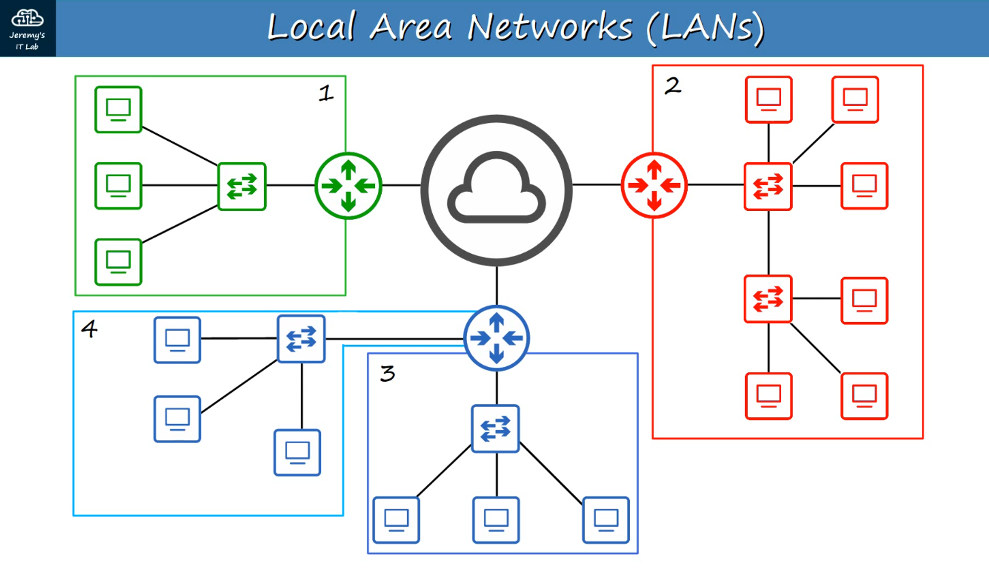

### **Structure of an Ethernet Frame**

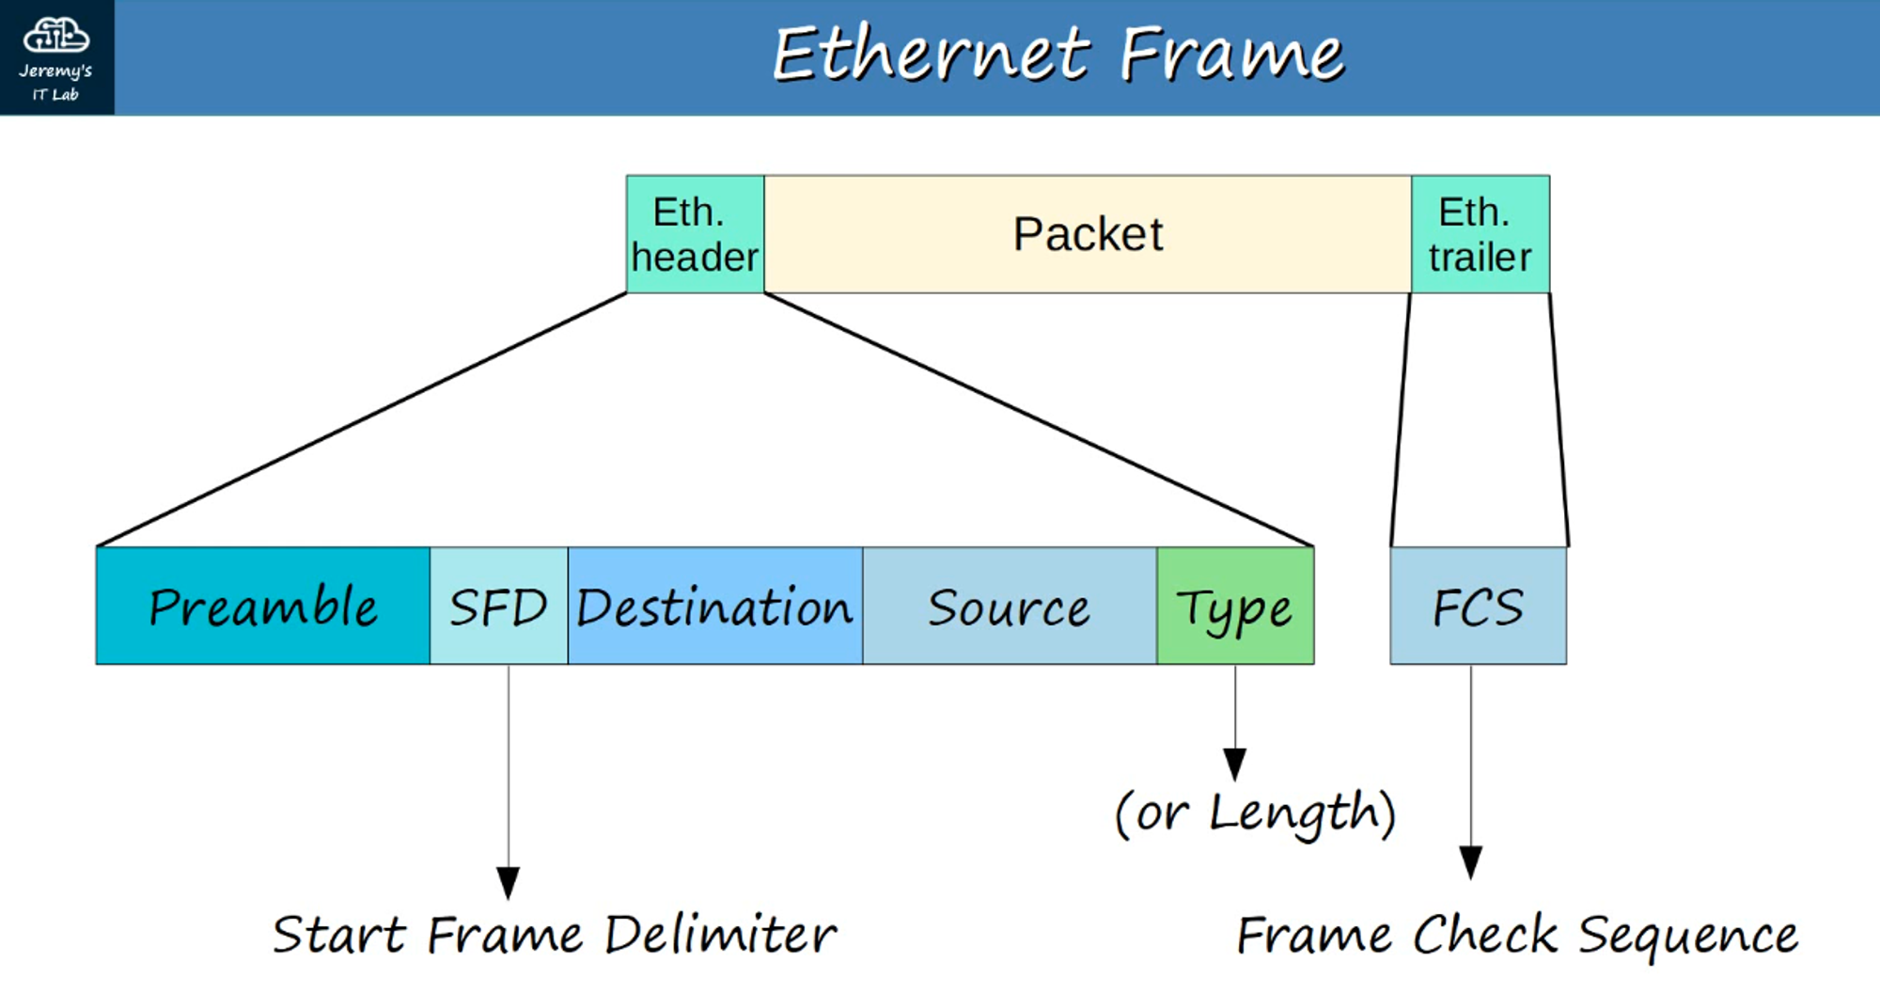

**Ethernet Frame:**

* **Ethernet Header** | **Packet** | **Ethernet Trailer**

#### **Ethernet Header Fields (26 bytes total):**

1. **Preamble**:  
   * **Length**: 7 bytes (56 bits).
   * Alternating 1s and 0s: 10101010 (repeated 7 times).
   * Allows devices to **synchronize receiver clocks**.
2. **SFD** (*Start Frame Delimiter*):  
   * **Length**: 1 byte (8 bits).
   * Value: 10101011.
   * Marks the **end of the preamble** and **start of the frame**.
3. **Destination and Source Address**:  
   * **Layer 2 Address** (MAC Address).
   * **6 bytes (48 bits)** each for source and destination.
   * Represents the **physical address** of devices.
4. **Type/Length Field**:  
   * **Length**: 2 bytes (16 bits).
   * Determines either:
     + **Length** of the encapsulated packet (if ≤ 1500).
     + **Type** of the encapsulated packet (if ≥ 1536).
   * Examples:
     + IPv4 = 0x0800 (2048 in decimal).
     + IPv6 = 0x86DD (34525 in decimal).

#### **Ethernet Trailer Field**

1. **FCS** (*Frame Check Sequence*):
   * **Length**: 4 bytes (32 bits).
   * Used for **error detection** via CRC (*Cyclic Redundancy Check*).
   * Detects corrupted data in the frame.

### **MAC Address**

* **Length**: 6 bytes (48 bits).
* Also known as the **Burned-In Address (BIA)**.
* **Globally unique** for every device.
* Structure:
  + First **3 bytes**: OUI (*Organizationally Unique Identifier*).
  + Last **3 bytes**: Unique to the device.
* Represented in **hexadecimal**: e.g., E8:BA:70:11:28:74.

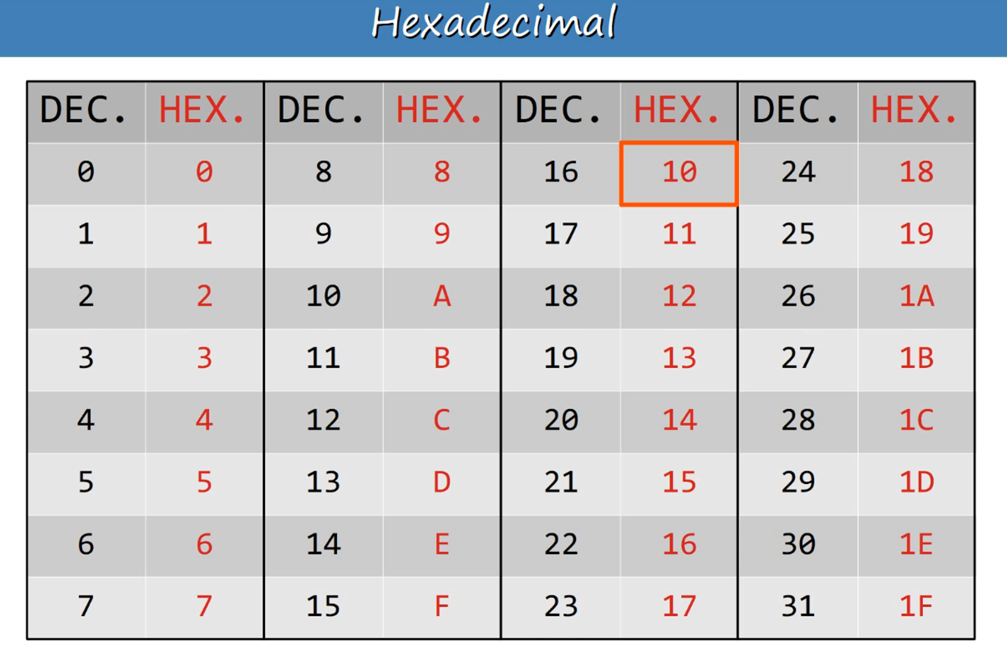

### **Interface Names**

* Common format: F0/1, F0/2, F0/3...
  + **F**: Indicates *Fast Ethernet* (100 Mbps interfaces).

### **MAC Address Table**

**Dynamic MAC Address Table**:

* A switch learns MAC addresses dynamically using the **Source MAC Address** from incoming frames.
* Stored MAC addresses allow efficient **frame forwarding** to the correct destination.

#### **Frame Forwarding Logic**

1. **Unknown Unicast Frame**:  
   * When the **Destination MAC Address** is not found in the MAC Address Table.
   * The frame is **flooded**: sent out on all interfaces except the one it was received on. Only devices that sent out frames will have their MAC Address learnt in the table.
2. **Known Unicast Frame**:  
   * If the Destination MAC Address is recognized, the frame is **forwarded** to the appropriate interface.

#### **MAC Address Table Timeout**

* Dynamic MAC addresses are **removed from the MAC Address Table** after **5 minutes of inactivity**.

